Moebelhaus shop is open, get your rental goods now!
TL;DR: The WHY2025 Moebelhaus shop for villages will be open between February 11 and April 22. To get a tent or furniture, this is the way: https://moebelhaus.why2025.org/

Renting of tents and furniture
WHY2025 will have villages. Villages are sub-camps which organise themselves, often a community around a topic or region. They often provide shared or public facilities such as facilities or workshops.
If your village wants a tent or furniture, the moebelhaus is there to help you out! In the moebelhaus shop, you can order 5x5m, 5x10m or 10x10m tents (other 5x5m size variations on request). In the next step, you can add chairs and tables to your tents as soon as you proceed your order with “continue” in your shopping cart.
If your village has a tent of its own, you can still order furniture. Please get in touch with Team:Moebelhaus and get a village furniture voucher to order all necessary furniture for your village.

Not part of a village?
In case you are not part of a village and want to order a few tables and chairs, please join a village and combine your order with them. This helps us to distribute furniture in a more consolidated and structured way. Thank you for your understanding!
The tents ordered with moebelhaus are for villages, and are not fit for sleeping in. For this purpose, please bring your own or order a KarTent with optional sleeping gear from the main ticket shop.

Distribution
We will monitor the arrival of villages during build-up of the event and drop the ordered furniture at the village location. For returning it during tear down, please stack the furniture so that we can pick it up again.
If there are any troubles, please get in contact with Moebelhaus directly: lumi_chan@c3moebelhaus.de

Parting words
There is a limited amount of items available in the Moebelhaus. In case something is sold out, this means we have to get in contact with our supplier to check for additional furniture availability. The Moebelhaus shop is open from Feb 11 to Apr 22. So take your chance and order your village tents now!
Example of rental items. Images courtesy of Boels Party:
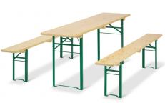Beer tent furniture set 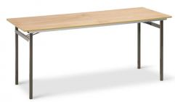Table 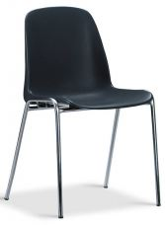Chair 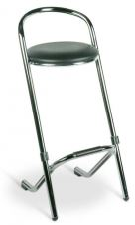Bar stool 

